

Functional Specification Documentation

For
Master Data Replication Program

Version No.: 1.0
Date: 28th February 2016

Table of Content
1. Overview Details 0
2. Update System Rate 1
3. Master Data Replication 4
4. Fields to be replicate to other entities 8

1. Overview Details

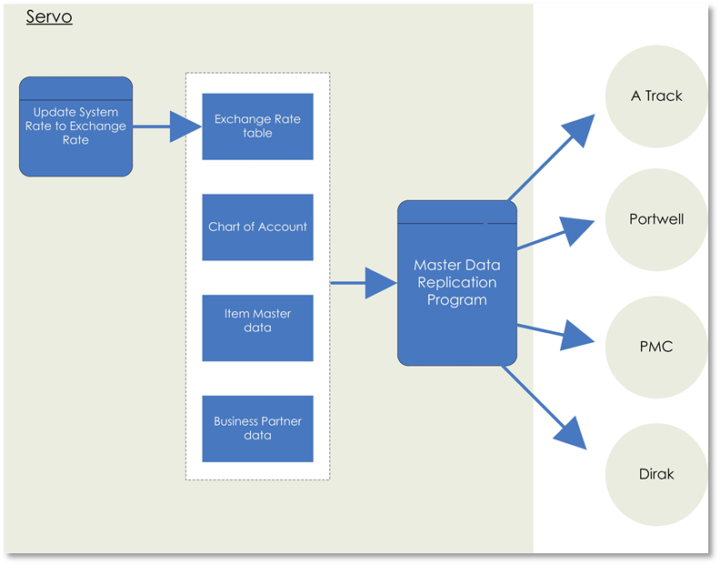

- Abeo will build below screen for ISDN to replicate below screens master data to other entities:

Screen 1: Update System Rate

Screen 2: Master Data Replication

- Exchange Rate
- Chart of Account
- Business Partner
- Item Master

- The replication will be hold in main entity ‘ISDN Holding’ database.

- Users will first create/update/delete in master data in the main entity.

- Go to replication program to replicate the all or selected item to selected entities.

2. Update System Rate

Requirement Description:

- User will update the Bank Rate, system will auto calculate the System Rate based on inputted Bank Rate and defined Tolerance rate and then update into exchange rate table.

- System Rate = [Bank Rate * Tolerance]. Administrator is allowed to change the tolerance value.

- The program will update the System Rate into exchange rate table and replicate to the selected companies.

Screen Design:

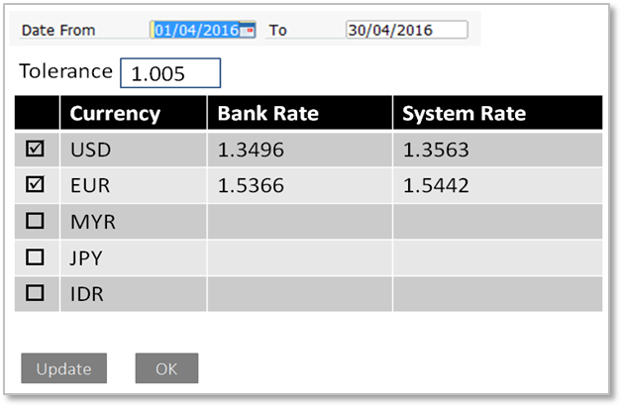

Seq. | Field Name | Standard/  UDF | Control Type | Default Value | Editable | Compulsory | Bus iness Rules
 | Date From..To.. | UDF | Calendar | NA | Yes | Yes | Specify a date range of up to one calendar month for which the fixed rate should be determined.
 | Tolerance | UDF | Textbox | NA | Yes | Yes | User Input.
 | Selection Column  ☑ / □ | UDF | Checkbox | NA | Yes | No | Select the currencies for which you want to determine a fixed exchange rate.
 | Currency | UDF | Textbox | Auto | Yes | Yes | Displays all the defined foreign currencies which pre-defined in Currency Table.
 | Bank Rate | UDF | Textbox | NA | Yes | No | Assign a rate for each currency you selected in the specified date range.
 | System Rate | UDF | Textbox | Auto | Yes | No | Bank Rate x Tolerance  Compulsory for the selected currency.
 | Update | UDF | Button |  |  |  | Assign System Rate to Exchange rate table.
 | OK | UDF | Button

Functional Specification

User: | Finance
Menu: | ➔ Customization → Update System Rate
Results | - System rate update into SAP Exchange Rate table.

Procedure
User Actions: |  | System Response:
- Select Exchange Rate from the menu. |  | - Exchange Rate screen open.
- Specify the Date From and Date To. |  | - Displays the selected date.
- Tick on the check box at the currency you want to update the exchange rate. |  | - Checkbox is ticked.
- Input Bank rate and press ‘Tab’. |  | - System Rate auto calculated.
- Click on ‘Companies’ button to select company to be update. |  | - Selected Companies.
- Click ‘OK’ to return back to the main screen. |  | - Back to Exchange Rate screen.
- Click ‘Update’ button. |  | - Save the System Rate  - Update System Rate to SAP Exchange Rate table.  - Update system rate to selected database.
Business Rules | - If user manually updates the rate at SAP Exchange Rate, the rate will not reflected at System rate.

3. Master Data Replication

Description:

- Abeo will build a program for Servo to replicate below master data to other entities:

- Exchange Rate
- Chart of Account
- Business Partner
- Item Master

- The replication will be hold in main entity ‘ISDN Holding database.

- Users will first create/update/delete in master data in the main entity.

- Go to replication program to replicate the all or selected item to selected entities.

Screen :
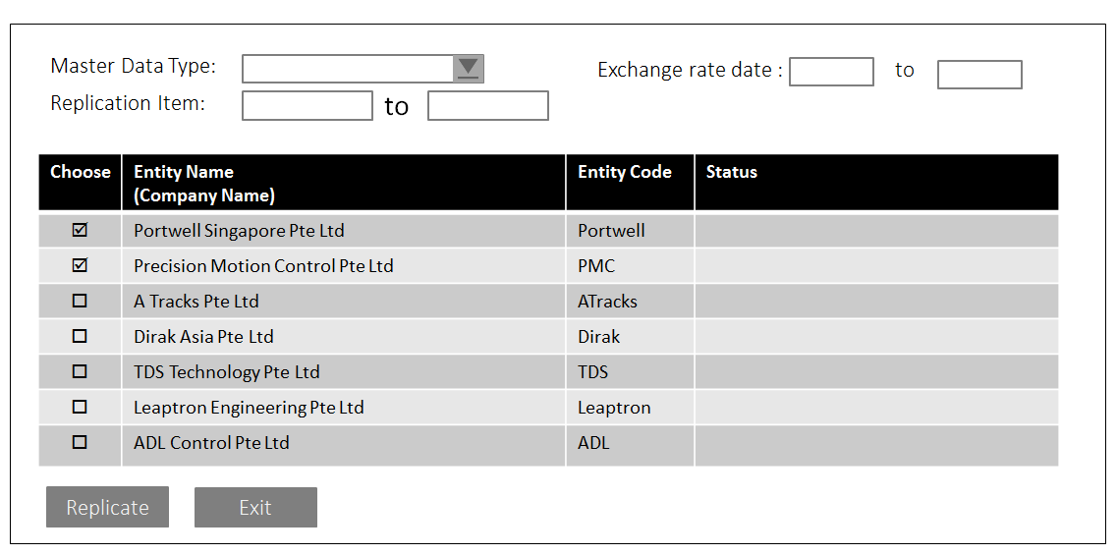

Seq. | Field Name | Standard/  UDF | Control Type | Default Value | Editable | Compulsory | Business Rules
 | Master Data Type | UDF | Dropdown | NA | Yes | Yes | Option:  Exchange Rate  Chart of Account  Business Partner Data  Item Master Data
 | Replication Item | UDF | Choose From List | NA | Yes | Yes | System will reflected below Listing based on selected Master Data Type.  Exchange Rate  List of GL Code  List of Business Partner  List of Item Master
 | Exchange rate date range | UDF | Calendar | NA | Yes | No | Enable only when master data type: Exchange Rate.
 | Choose  ☑ / □ | UDF | Selection Column | NA | Yes | Yes | Select the company to replicate.
 | Entity Name | UDF | Textbox  (100) | Auto | No | Yes | Company name
 | Entity Code | UDF | Textbox  (10) | Auto | No | Yes | Database name
 | Status | UDF | Textbox  (Free text) | Auto | No | Yes | The result will be reflected in this column once the replication is completed.
 | Replicate |  | Button | NA | NA | NA | Replication process.
 | OK |  | Button | NA | NA | NA | Click ‘OK’ to close the window.

Functional Specification

User: | Finance
Menu: | ➔ Customization → Master Data Replication
Pre-requisition | N/A
Results | - System will replicate selected master data type to selected entities.

System Procedure
User Actions: |  | System Response:
- Click Master Data Type drop down. |  | - Display Option:  - Exchange Rate  - Chart of Account  - Business Partner Data  - Item Master Data
- Click Replication Item Choose To List from |  | - Displays listing based on selected master data type.
- Click on the checkbox for the company to be replicate. |  | - Checkbox is ticked.
- Click ‘Replicate’ button. |  | - System replicates master data to the select entities.  - Result show on the Status column.
- Click ‘Exit’ button. |  | - Master Data Replication screen closed.
Business Rules | System will apply below business rules based on Master Data Type.  - Exchange Rate: The following business rules will be applicable when Master Data Type is in ‘Exchange Rate’.  - Exchange Rate Date enabled.  - Replication Item Choose List From and To will be list down exchange rate data.  - System will replicate exchange rate to the selected entities based on the selected Exchange Rate Date range and selected currency code.  - Chart of Account: The following business rules will be applicable when Master Data Type is in ‘Chart of Account’.  - Replication Item Choose List From and To will be display a list of GL account.  - System will replicate selected GL code to the selected entities.  - Only Postable account (active account) will be replicate.  - Business Partner Data: The following business rules will be applicable when Master Data Type is in ‘Business Partner Data’.  - Replication Item Choose List From and To will be display a list of Business Partner.  - System will replicate selected BP code to the selected entities.  - Item Master Data: The following business rules will be applicable when Master Data Type is in ‘Item Master Data’.  - System will cross check the selected item name if exist in the selected entities.  - If exist, mark as ‘Global item’.  - If no, no action required.  (b). Item Description (Supplier Part No) must be unique.  Item codes (stock code) may be different across entities.
  Code | Currency | System Rate
  USD | US Dollar
  EUR | Euro
  GL Account | Name
  BP Code | Name | Card Type
   |  | Customer/ Vendor

4. Fields to be replicate to other entities

Exchange Rate

Table name: ORTT
No | Field Name | Description
 | CurrName | Currency
 | Rate | Rate

Chart of Account
Table name: OACT
No | Field Name |  | Description
 | Account [Active / Title] |  | Parent Account key
 | Account Code |  | Budget
 | Account Name |  | Account Category
 | Cash Account [Y/N] |  | Account Currency
 | Account on Hold [Y/N] |  | Lock Manual Transaction
 | Account level |  | Active
 | External Code |  | Active From
 | Cash Flow Relevant [Y/N] |  | Active To
 |  |  | Active Remarks
 |  |  | Inactive
 |  |  | Inactive From
 |  |  | Inactive To
 |  |  | Inactive Remarks

Business Partner

Table Name: OCRD (General) | Table Name: OCPR (Contact Person)  Table Name: CRD1 (Address)
  No | Description
   | BP Code
   | BP Name
   | BP Type
   | Group Code (Industry)
   | Foreign Name
   | Currency
   | Preferred Currency
   | Company Reg. No.
   | Telephone 1
   | Telephone 2
   | Mobile
   | Fax Number
   | E-Mail
   | Web Site
   | Shipping Type
   | Shipment Term
   | Region
   | Sub-Industry
   | Sales Employee
   | Sales Admin
   | In-house Sales
   | Required Position No?
   | Required Project No?
   | Payment Terms
   | Credit Limit
   | Account Receivable/Payable
   | Down Payment Clearing
   | VAT Status
   | VAT Code
  No | Description
   | Properties
   | Remarks
  No | Description
   | Contact ID
   | Position
   | Telephone 1
   | Telephone 2
   | Mobile Phone
   | Fax
   | E-Mail
   | Remarks 1
   | Remarks 2
   | Profession
  No | Description
   | Address ID
   | Addr. 1
   | Addr. 2
   | Addr. 3
   | Addr. 4
   | PostCode
   | Country
   | Tel No
   | Fax No.

